# OnFest

# Created on March 02 2018

# Table of Contents

1.0. Information

2.0. Line-Up

# 1.0. Information

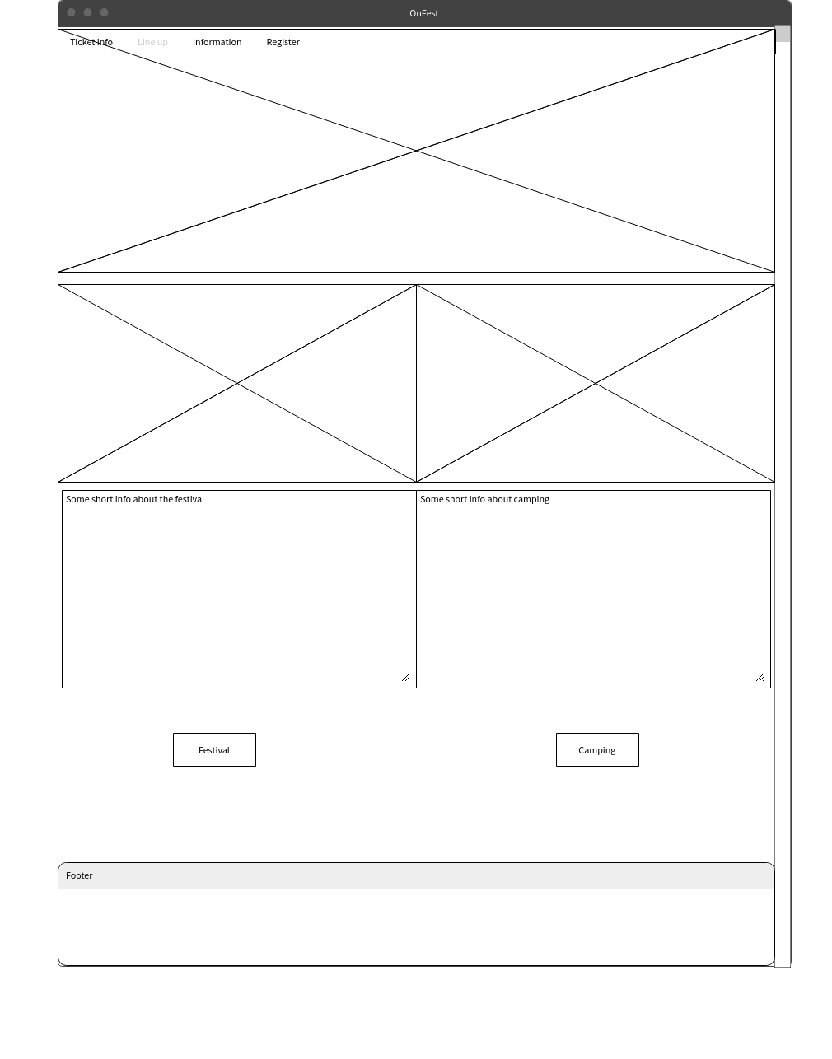

# 2.0. Line-Up

